Case Studies

For

Director of Public Health Report
2024

Case Study: The Staffordshire County Council Supportive Communities Programme

The Supportive Communities Programme helps more people to draw on their strengths and the support available around them in their communities.

In 2018 roughly three quarters of initial requests for adult social care were for support that is available in communities - such as help with shopping or information to reduce loneliness. The Supportive Communities Programme was launched in April 2020 to try and make it easier for people to help themselves and reduce demand for health and care services.

The vision for Supportive Communities is that “People in Staffordshire can live independently with support from their families and communities”.

The Supportive Communities priorities are:

Priority 1: Develop tools for promoting independent living (using digital and non-digital means).
What we have done
A range of online tools to help people access information and advice are available including:
- The county council’s webpages, which have been reviewed and revised, with input from Members, Community Champions and social prescribers.
- Staffordshire Connects, an online directory of organisations and activities which currently hosts almost 5,000 entries.
- The Happy at Home interactive house (Happy at Home - Staffordshire County Council) and a benefits calculator (Benefit calculator (entitledto.co.uk)).

Priority 2: Grow and enhance community capacity for communities to help themselves and others.
What we have done
- The assistive technology ‘bag of trix’ and ‘box of trix’ available to Community Help Points and social care staff to help them demonstrate the range of equipment available to help promote independence at home
- We resource the Voluntary and Community Sector through a range of grants schemes and 350 organisations have been supported since 2020
- We have a partnership contract with Support Staffordshire who support our work and help us connect with the Voluntary Sector
- We have 26 Community Help Points and will be developing our locality approach as we move forward

Priority 3: Help to develop the skills, knowledge and confidence of the wider care & community workforce.
What we have done
We provide bespoke training modules for volunteers, community organisations and social care staff, on topics such as signposting, communication and assistive technology, as well as working closely with adult social care teams to better understand the opportunities and challenges they face, highlighting the importance of taking a strengths-based approach and developing local networks.

Priority 4: Effective communication & engagement with both communities and the workforce.
What we have done
- A network of Community Champions has been established to share health and wellbeing messages with communities. We now have 57 people as Community Champions across the county.
- A range of campaigns and citizen’s inquiries have also enabled communication with the public, inviting communities to tell us what is important to them.

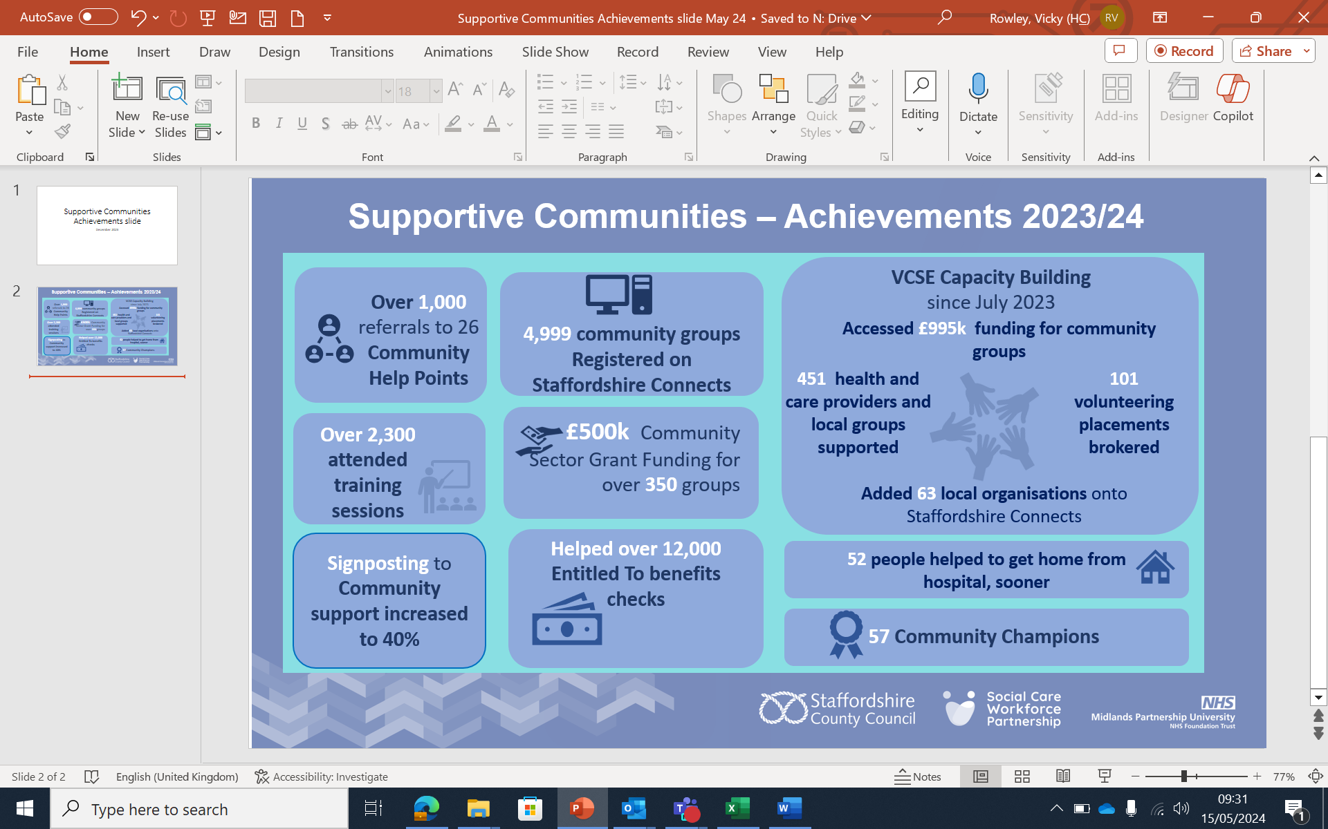
Supportive Communities: Achievements

Case study: Staffordshire Community Help Points

Staffordshire County Council is always looking for ways to improve connections in our communities. In 2020 the county council launched Community Help Points as one way to help residents navigate support for a wide range of issues near them.

Community Help Points are supported by a variety of Council employees and community organisations, who all receive additional training on how to help residents. From befriending and signposting to formal health and care support, local clubs and volunteering opportunities, Community Help Points are one way the council is supporting Healthy Aging. By increasing a person’s connections to their local community, the council works alongside community organisations to tackle the physical and mental impacts of social isolation, while empowering people to choose how they could develop their circle of support. The support also contributes to reducing the need for social care intervention.

Recently J was referred to Rugeley Community Church for help with finding social opportunities in the community. Struggling with deteriorating eyesight and anxiety, J found herself often stuck at home since her husband died. After an initial phone call the Church was able to recommend various social activities and opportunities across the Rugeley area and also referred J into Beacon, a West Midlands charity supporting people with sight loss.

Beacon are now helping J access bereavement support, looking at volunteering opportunities for J to widen her circle of friends and ways to improve J’s travel options. Within less than 2 months J has gone from being isolated and lonely to having a healthy range of opportunities and support to help her increase confidence, make friends, stay safe and feel supported through such a challenging time.

There are 26 Community Help Points across the county supporting an average of 40 people a month.

Find out more about Community Help Points on our website www.staffordshire.gov.uk

Case Study: Healthy Aging – A Social Prescribers story

Social Prescribing is an NHS approach which connects people to activities, groups, and services in their community to meet the practical, social and emotional needs that affect their health and wellbeing. Social prescribing link workers give people time, focusing on what matters to them, to help connect them with their community.

A 76-year-old man from Stafford was referred by General Practice for support with feeling lost, inactivity and wanting to increase engagement with society.

Initial contact from a social prescriber was an introductory telephone call. The man felt his mood was getting worse because he was feeling more and more isolated since Covid. The man was married but had seen his weight dropping and had lost interest in things he liked doing such as cooking and model making. The social prescriber explored his interests, and the telephone conversation ended with a booking for a face-to-face appointment. The man was tasked to cook something special over the next few days.

The man arrived for a face-to-face meeting supported by his wife, he was already much more positive after one discussion and had started cooking again. During the appointment the social prescriber introduced the patient to the U3A (University of the Third Age) website and discussed other interests like model making.

At the follow up appointment the man had continued to cook and was still enjoying it. He had enrolled on an activity with U3A called First Story. This explores past life experiences and people are encouraged to write these stories down and reflect with the group. He was also helped to find model making groups in Stafford.

The man said, ‘You changed my outlook and introduced me to things I had no idea were happening in Stafford. Thank you so, so much, please keep in touch.’

A range of organisations and activities can also be found on Staffordshire Connects by following this link Staffordshire Connects | Adults and Communities

Read more about Social Prescribing on the NHS England website - www.england.nhs.uk/personalisedcare/social-prescribing/

