Self-Assessment Help Sheet

This guide is to help you fill in your self-assessment.
We will list things to think about when you fill in each section.

You don’t need to tell us about everything we’ve listed, just the things that matter to you.

Section 1: Personal Details

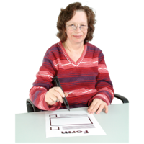
This section is about the person who is filling in the assessment.

It asks things like whether you are a UK citizen and who to contact in an emergency.

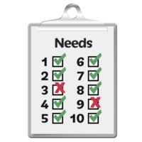
Section 2: Tell us about you

This section is about your everyday life and will help us to find out where you need support.

Section 3: What you do each day
This section is in 4 parts:

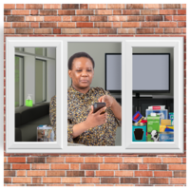
Section 3a: Living at Home
Here, you can tell us about things like:

Washing yourself
What do you do to keep clean.
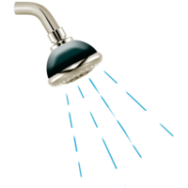
This could be:
- Having a bath or shower
- Brushing your teeth and hair
- Shaving

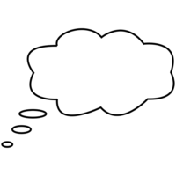
Think about:
- Do you need help to have a wash or get dressed.
- Do you have a seat or rails to hold when you are in the shower.
- Can you wash and dry yourself safely.

Using the toilet
Tell us about things like:
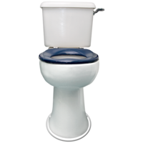
- Do you know when you need to go to the toilet or does someone need to remind you.
- Can you use the toilet on your own.
- Can you clean yourself properly after you have been to the toilet or does someone else help you.
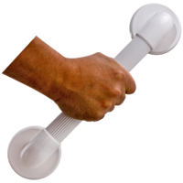
- Do you hold on to a rail when you are on the toilet or to help you get off the toilet.
- Do you wear pads in your pants in case you don’t get to the toilet in time.

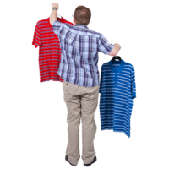
Taking care of how you look

Tell us about how you do things like:
- Changing your clothes
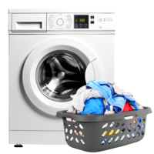
- Washing your clothes
- Looking after your hair
Are any of these things getting hard for you.

Contingency Plans

This means what you would do if you had an emergency at home.
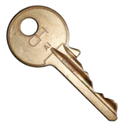
Tell us about things like:
- Who has keys to your house.
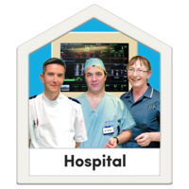
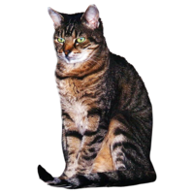
- If you have pets, where would they go if you needed to go to hospital.
- There are also questions in this section about being deaf or blind.

Section 3b: Eating and Drinking

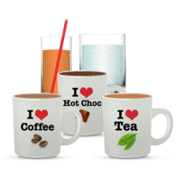
Drinking
If you don’t drink enough water, you can get headaches and feel tired.
Tell us about how often you have a drink and what you drink each day.

Eating
Tell us about things like:
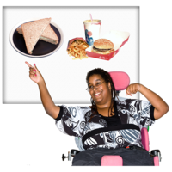
- How many meals you eat each day.
- Whether you like to snack or have a big meal.
- Does someone need to remind you to eat.

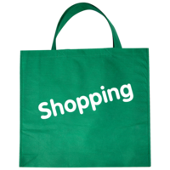
Food Shopping
Tell us how you plan your food shopping:
- Do you look in your fridge and cupboards to see what you need.
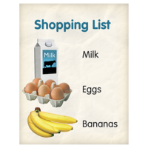
- Do you write a list.
- Do you go to the shops, or do you order your food shopping online.
- Can you do these things yourself or does someone else help you.

Making your Meals
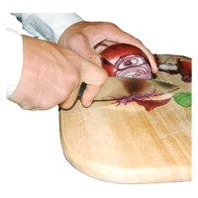
- Do you make your own meals or is this difficult for you.
- Does a carer or someone from your family help you.
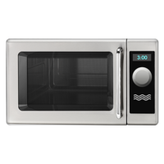
- Do you have meals delivered to you ready to eat.
- Do you use a microwave to heat your food, and do you feel safe doing this.

Enjoying your food
It is important to enjoy your food.

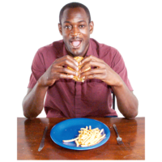
Tell us about your meals:
- Do you sit at a table and is this comfortable for you.
- You can tell us what you think might make eating easier for you.
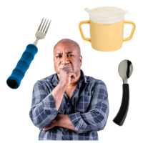
- Can you use knives and forks and hold a cup easily.
- Tell us if you have any health conditions that make it difficult for you to eat.

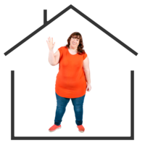
Section 3c: Keeping your home safe
In this section, tell us about how you keep your home safe.

Going Out
Think about how you make sure your house is safe when you go out.

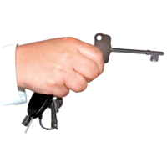
- Do you lock the doors, and can you open the door easily when you get home.

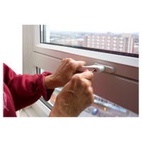
- Do you make sure all the windows are closed before you go out.

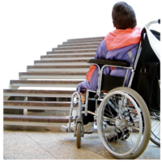
- Are there any steps outside your home that you find difficult to get up or down.

Getting around your house
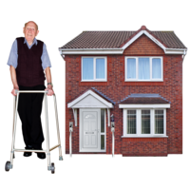
Think about how you get around your home:

- Can you get around your home easily and safely.
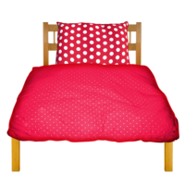
- Can you get into and out of bed easily.

- Does someone help you with the things we’ve listed above.
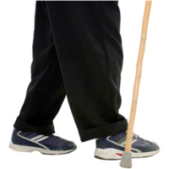
- Do you have things to make it easier like a walking stick or a special bed.

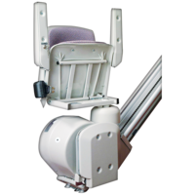
- Has your home been changed to make it easier for you. This could be something like a stair lift or ramps.

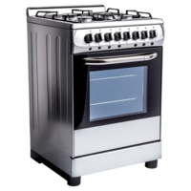
Home Appliances
These are things like ovens and heaters.
- Can you use things like this without hurting yourself.

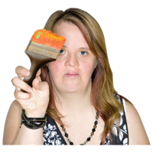
- Do you do any repairs on your home or does someone else do this for you.

Paying Bills
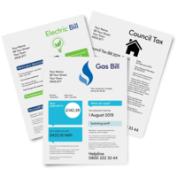
Sometimes it can be hard to keep track of things that you need to pay for like:
- Water
- Electricity
- Gas
- Rent or mortgage payments

- Can you pay your household bills by yourself.

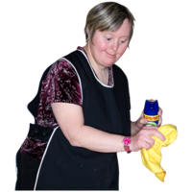
Cleaning

It is important to clean your home, especially the kitchen and bathroom.

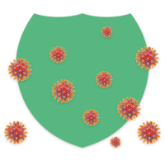
This will stop your home getting dirty and stop germs that may make you feel ill.
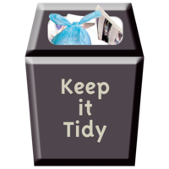
Keeping your home tidy will stop you from tripping over things and can help you feel happier.
- Can you keep your house clean and tidy.

Section 3d: Getting out and about
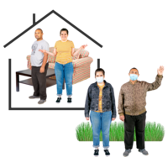
This section is about going out.

Going out:
- Can you get to the shops and appointments by yourself.
- Do you go to local activities that you enjoy.
- Do you need someone to help you when you leave your home.

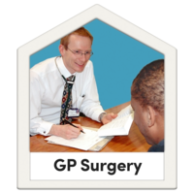
Attending Appointments:
You might need extra help when you go to doctor or hospital appointments.
This may be because:
- You find it hard to understand or remember things.
- You need help to make a hard choice.
- Talk to the doctor’s surgery or the hospital if you need help.

Being part of the community
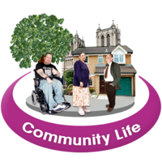
We all feel good if we are part of a community.
- You might want to go to work or have a volunteering role.
- You could join a training course or study at college.
- If this sounds good, there are lots of ways to join in.
- Do you know where to look to find out how to do these things.

Travel
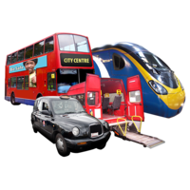
There are lots of ways to travel:
Walking
Cycling
Taking a taxi
Getting a lift from a friend
Catching the bus
- Can you travel safely to where you need to get to.

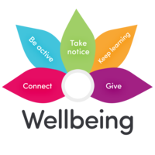
Section 4: Health and Wellbeing

Relationships
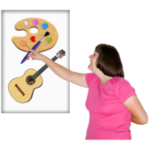
Having hobbies can make you feel good. Hobbies can help you meet new people and make new friends.

- Do you have the chance to meet new people and make new friends.
- Can you meet up with family and friends. This can be at home or going out.
- Do you need any help to contact family and friends.
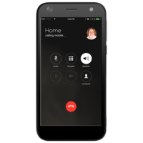
- Phones and computers can help you keep in touch with your friends.
- Can you use things like this.

Looking after some-one else
Do you help to look after someone else.
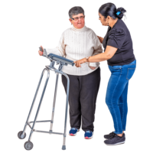
This could be:
- Your children or grandchildren
- A relative or friend
- If you do, tell us how you feel about doing this.
- Is it hard for you to help someone else.
- Do your own needs make this difficult.

Your Health
It’s important that you tell us about any long-term illnesses or conditions that you have.
- How do these affect you every day.
- Do they stop you doing things that you enjoy.
- What do they stop you from doing.

Section 5: Your Money
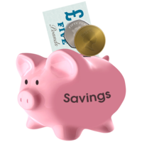
This section asks questions about how you look after your money, pay bills, and save.

It also asks if you have anyone who helps you look after your money.

Section 6: Additional Information
This is the last section and is for you to tell us anything else that you want us to know.

