|  |  |
| --- | --- |
|  |  |

Economic Bulletin

Issue 1 – July 2020

Welcome to the first edition of the new Staffordshire & Stoke-on-Trent Economic Bulletin produced by our Economy, Skills and Insight Teams, which provides the timeliest secondary data available on what is happening with the local economy. However, this clearly only provides part of the picture and over the coming months we intend to build up our softer intelligence to provide a better indication of what is happening on the ground, including the local response to the COVID-19 crisis.

Alongside information on the Claimant Count and Job Vacancies that will be a part of every Bulletin, this month’s issue also looks at the Coronavirus Job Retention Scheme (CJRS) Furloughed Workers and Self-Employment Income Support Scheme (SEISS) to assess how these schemes are being used in Staffordshire & Stoke-on-Trent.

We hope you find the Bulletin useful and welcome your comments and suggestions on further information you would like to see included in future editions. If you do have any feedback please send your comments to Darren Farmer, Economy & Skills Analyst at darren.farmer@staffordshire.gov.uk.

Stay Safe,

Darryl Eyers

Director for Economy, Infrastructure and Skills, Staffordshire County Council



**Key Messages**

* For the first time this bulletin looks at the full picture now and helps predict local impact into the future - claimant count figures and job vacancies, but also the use of the government initiatives including the Job Retention Scheme, furloughed workers and Self- Employment Incomes Support Scheme and what this tells us.
* The number of people on government support is largely on a par with the rest of the country (32% versus 31% nationally).
* The claimant count saw a slight decline of 915 between May 2020 and June 2020 to a total of 26,135 claimants and a rate change from 5.1% to 4.9% of the working age population - however, not all will be out of work. Whilst there has been some announcements of potential redundancies, due to the move to Universal Credit claimant count figures now also include those that have had a lower income through Covid-19, including furloughed staff and part time employees, short-term layoffs and self-employed that have paused or ceased operating.
* The claimant count rate is still relatively low in Staffordshire (4.9%) compared to regionally (7.2%) and nationally (6.4%), however, and unsurprisingly young people, the lowest paid and part-time workers are feeling the impact of the economic shock the most. Several recent announcements made by the Chancellor through ‘A Plan for Jobs 2020’ are aimed at supporting these groups and are to be very much welcomed.
* However, we must all expect difficult times to come. The number of furloughed workers is the second highest in the region at nearly a third, largely due to slightly higher employment in the higher risk sectors (retail, hospitality, manufacturing, construction, arts and entertainment), and although the recent government announcements will help to soften the blow, with the gradual withdrawal of the Job Retention Scheme, we can expect more job losses to come.
* Although the number of job vacancies has also decreased, this is to be expected and is happening everywhere - and there are early signs that the job market is picking up. We have seen, like everywhere, a considerable increase in vacancies in the high growth sectors such as key worker roles in health and social care, digital and the green economy.
* In conclusion, it is clear that the peak of the lockdown did hit Staffordshire hard, although things are absolutely starting to improve as we work together to reignite the economy. Our main focus now must be on working together to ensure that as many people as possible currently on furlough return to work, even if that’s not into their original roles.
* With that in mind, the Redundancy and Recruitment Triage Service will now be more important than ever. Staffordshire and Stoke-on-Trent was one of the first places in the country to set up this rapid-response service to support businesses who sadly simply have to restructure, and those individuals to discover their skills and qualities that match them to roles and careers that they may not have thought about before.
* Whilst this service will certainly help, it is not the complete answer. The County Council and our local partners have made numerous interventions over the last few months to support our residents and businesses including:
  + Discretionary grants distributed through to businesses by our Districts and Boroughs;
  + The Staffordshire County Council emergency grants scheme to help support our micro-businesses survive the crisis;
  + The Staffordshire County Council Start-up support scheme delivered by the Chambers of Commerce;
  + The giving away of small packs of Personal Protective Equipment (PPE) to businesses through the PPE Start-Back Scheme to support them in operating under Covid-Secure guidelines, whilst also offering [advice on how to use PPE](https://www.staffordshire.gov.uk/Business/Coronavirus-COVID-19-support-for-businesses/Emergency-PPE/Help-to-use-PPE-correctly.aspx) and where to [buy safe, cost-effective PPE from trusted suppliers](https://www.staffordshire.gov.uk/Business/Coronavirus-COVID-19-support-for-businesses/Emergency-PPE/PPE-Suppliers.aspx).
* Over the coming months we intend to continue to work with partners to build up a comprehensive local picture of what is happening within the local economy and interventions that have been put in place.

|  |
| --- |
| **Local Picture – Residents on Government Support Schemes**  Several economic support measures have been tailored or introduced to support jobs and businesses through the COVID-19 crisis in response to the lockdown measures that have been, and for some sector continue to be, in place. Of particular relevance to the monitoring of the local impact of the crisis is the number of people claiming Universal Credit (Claimant Count), and the number of people on the Coronavirus Job Retention (CJRS) and Self-Employment Income Support Schemes (SEISS), as seen below.  **Overall Number of Residents on Government Support Schemes**    In line with the Claimant Count rate which shows the proportion of the working age population claiming Universal Credit we have calculated the proportion of the working age population which may be on the furloughed or SEISS support schemes.  In total there are potentially just over 242,000 residents in the SSLEP on Government support equivalent to over a third (35%) of the working age population compared to 34% in England. Tamworth (40%) and Cannock Chase (39%) have the highest rates while Newcastle-under-Lyme and Stafford (both 30%) has the lowest.    **Detailed Breakdown**  **Claimant Count[1]**  The following table highlights the level of claimant unemployment in the Staffordshire Districts and each of the Strategic Authorities in the West Midlands Region:  **Claimant Count (Universal Credit) Statistics: June 2020**     * The Claimant Count in Staffordshire saw a slight decrease of 915 between May 2020 and June 2020 to a total of 26,135 claimants. Stoke-on-Trent also saw a slight decline of 45 over the same period with a total of 12,945 claimants in June. * These slight declines in June are similar to the trend seen nationally and is likely to reflect some movement of people initially claiming Universal Credit at the start of the crisis but during June have moved to the Furlough/SEISS support schemes. * This is shown in the latest Furlough and SEISS support scheme figures for June, where there was an increase of 17,400 furloughed workers in Staffordshire compared to May and a 5,000 increase in Stoke-on-Trent. While SEISS claims increased by 1,500 in Staffordshire between May 2020 and June 2020 and by 700 in Stoke-on-Trent. * This is why it is so important to look at the Claimant Count alongside the Furlough and SEISS schemes to help understand the full picture. * It is also important to look at the change in the Claimant Count seen since March 2020 (pre-COVID) where the number of claimants in Staffordshire has more than doubled with an increase of 14,085 claimants and in Stoke-on-Trent there has been an increase of 5,625. * Ultimately, the full effect of COVID-19 on employment will not be felt until the furlough and SEISS schemes come to an end. * The increases in the Claimant Count also need to be viewed in the context of the move to Universal Credit. Before Universal Credit, the Claimant Count was based upon Jobseeker’s Allowance claimants, i.e. people out of work but looking for a job. A proportion of claimants currently will have a job but claiming Universal Credit due to having a low income - the reasons for the increase in claimants are still to fully emerge but evidence suggests there will be a combination of factors such as:   + New Job Starters/PT employees/Self-employed with no income claiming Universal Credit because they are not eligible for the CJRS;   + Self-employed ceased trading or have very low income claiming Universal Credit (and are either not eligible for, or not yet been paid, income under the SEISS);   + Working part-time low-income workers claiming Universal Credit and may be furloughed;   + Potential Redundancies within Small & Medium Enterprises laying off staff in the short-term. * Unfortunately, due to data limitations it is not currently possible to quantify the proportion of people that fall into these cohorts at a local level. * Given the comparatively strong position of Staffordshire going into the pandemic and the fact that COVID-19 has impacted much of the economy during lockdown, even with the significant increase in claimants the proportion of working age residents on such benefits remains comparatively low in Staffordshire with a rate of 4.9% in June compared to 7.2% regionally and 6.4% nationally. In Stoke-on-Trent the Claimant Count rate remains above both the regional and national averages at 8.1%. * As well as workers across sectors being impacted differently, there are also signs that it is the lowest paid, part-time workers and young people (particularly apprentices) that are being hardest hit. These groups are more likely to work in sectors that have shut down or reduced activity, such as hospitality and non-essential retail. They are also less likely to be able to work from home. * Young people aged 18-24 continue to be disproportionately impacted by unemployment; the claimant rate for young people in Staffordshire increased from 3.7% in March to 8.3% in June compared to a rise from 2.3% to 4.9% for all working-age residents, while in Stoke-on-Trent the rate has risen from 5.9% in March to 11.0% in June. * All Staffordshire Districts have seen a slight decline in the number of claimants with the exception of East Staffordshire which saw an increase of 80 in June. Tamworth and Cannock Chase continue to record the highest rates in Staffordshire, although East Staffordshire and Newcastle-under-Lyme have the largest caseloads. However, it’s important to note all Districts remain lower than the current national and regional rates.   **Claimant Counts and Rates in Staffordshire & Stoke-on-Trent Wards**   * The following maps and tables provide the latest breakdown of the claimant count by wards in Staffordshire & Stoke-on-Trent.   **Claimant Count Rate June 2020**  Out of the 201 wards in Staffordshire & Stoke-on-Trent, 58 were at or above the England average of 6.4% for the number of claimants as a proportion of the working age population.  The top 10 wards with the highest claimant count rate were all in Stoke-on-Trent with Joiner’s Square (13.4%), Etruria and Hanley (12.8%) and Moorcroft (12.8%) having the highest rates.  In Staffordshire, Burton (9.3%) and Shobnall (9.2%) both in East Staffordshire had the highest claimant count rates.    **Change in Claimant Count since March 2020**    The top 3 wards with the highest change in the number of claimants since March 2020 were all in Stoke-on-Trent and included Birches Head and Central Forest Park (330 increase to 720 in total), Baddeley, Milton and Norton (305 rise to 635 in total) and Etruria and Hanley (290 rise to 645 in total).  **Youth Claimant Counts and Rates in Staffordshire & Stoke-on-Trent Wards**  The following maps and tables provide the latest breakdown of the youth claimant count by wards in Staffordshire & Stoke-on-Trent.  **Youth Claimant Count Rate June 2020**  Out of the 201 wards in Staffordshire & Stoke-on-Trent, 91 were at or above the England average of 9.1% for the number of claimants aged 18-24 as a proportion of the 18-24 population.  Of the top 10 wards with the highest youth claimant count rate 5 were in Stoke-on-Trent including Joiner’s Square (19.3% - the highest in SSLEP area), Moorcroft (17.2%), Bentilee and Ubberley (15.9%), Burslem Central (15.7%) and Bradeley and Chell Heath (15.6%).  In Staffordshire, the highest rate was Glascote in Tamworth with 16.4%, followed by Cannock South (15.7%), Knutton in Newcastle-under-Lyme (15.4%), Stapenhill in East Staffordshire (15.4%) and Curborough in Lichfield (15.4%).    **Change in Youth Claimant Count since March 2020**    The top 3 wards with the highest change in the number of youth claimants since March 2020 were all in Stoke-on-Trent and included Birches Head and Central Forest Park (65 increase to 135 in total), Etruria and Hanley (60 rise to 105 in total) and Bentilee and Ubberley (55 rise to 145 in total).  **Coronavirus Job Retention Scheme (CJRS) Furloughed Jobs[2]**   * **Staffordshire had the 2nd highest number of furloughed job claims up to the end of June in the WM with 128,800** behind only Birmingham and equivalent to just under a third (32%) of eligible workers. * **Staffordshire’s rate of furlough is in-line with the regional average (32%) and slightly above the national (29%) average.** * **Stoke-on-Trent had 36,100 furloughed jobs** equivalent to just under a third of eligible jobs (32%).   **Coronavirus Job Retention Scheme (CJRS) Statistics: June 2020**     * Nationally, the identified high-risk sectors are amongst the highest for the number of jobs that have been furloughed:   **Coronavirus Job Retention Scheme (CJRS) Claims by Sector: June 2020**     * Beyond the short-term, specific industrial sectors and the associated labour market may continue to be adversely affected, particularly due to changes to economic support measures and market conditions. A particular risk is the forthcoming changes to the Government’s Job Retention Scheme (JRS) which has enabled many people to remain in employment but furloughed during the lockdown. Whilst the scheme has been extended to October, it is being gradually withdrawn from August onwards and this may lead to potential further increases in unemployment.   **Self-Employment Income Support Scheme (SEISS)[3]**   * **Staffordshire has seen 30,100 self-employed workers claim through SEISS up to the end of June**, which is second only to Birmingham in the WM and a take-up rate of over three quarters (76%) for those eligible through the scheme just above the regional and national averages of 75%. * **Stoke-on-Trent 8,300 SEISS claims,** equivalent to 78% of those eligible.   **Self-Employment Income Support Scheme (SEISS) Statistics: June 2020** |

**Job Vacancies[4]**

* Job vacancies in Staffordshire have also been heavily hit, where between Feb 2020 (pre-COVID) and June 2020 there was **decline in job vacancies of 37% equivalent to over 6,800 fewer job vacancies. Stoke-on-Trent saw a 33% decline with just over 2,200 fewer vacancies** in June compared to Feb.
* **Staffordshire higher decline than seen nationally (30%)** and we have also seen a larger year on year decline than seen nationally, this likely reflects Staffordshire’s economic structure where sectors and occupations hardest hit by COVID-19 make up more of our local economy and therefore recruitment has declined more substantially.
* Although between May and June there are potentially early signs that demand for labour is starting to pick back up.

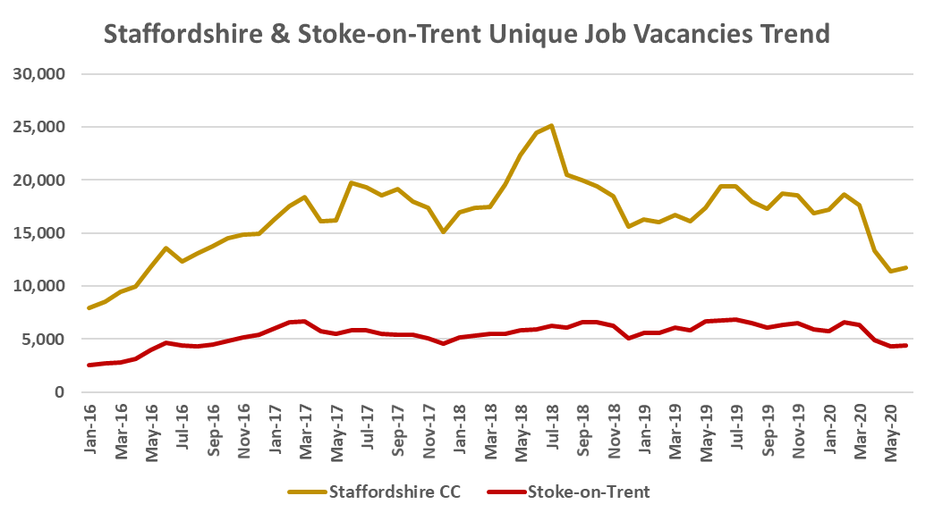

* There has been a decline in vacancies for most occupations as a result of the crisis, but particularly within sectors and roles hardest hit by the lockdown. The only real exceptions are social care workers and home carers with demand for these workers, alongside nurses, remaining by far the strongest of all occupations.

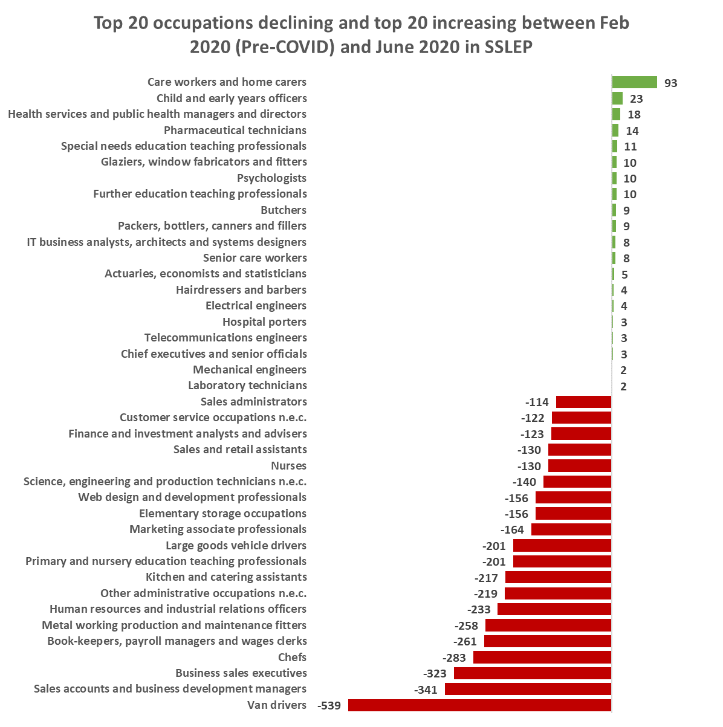

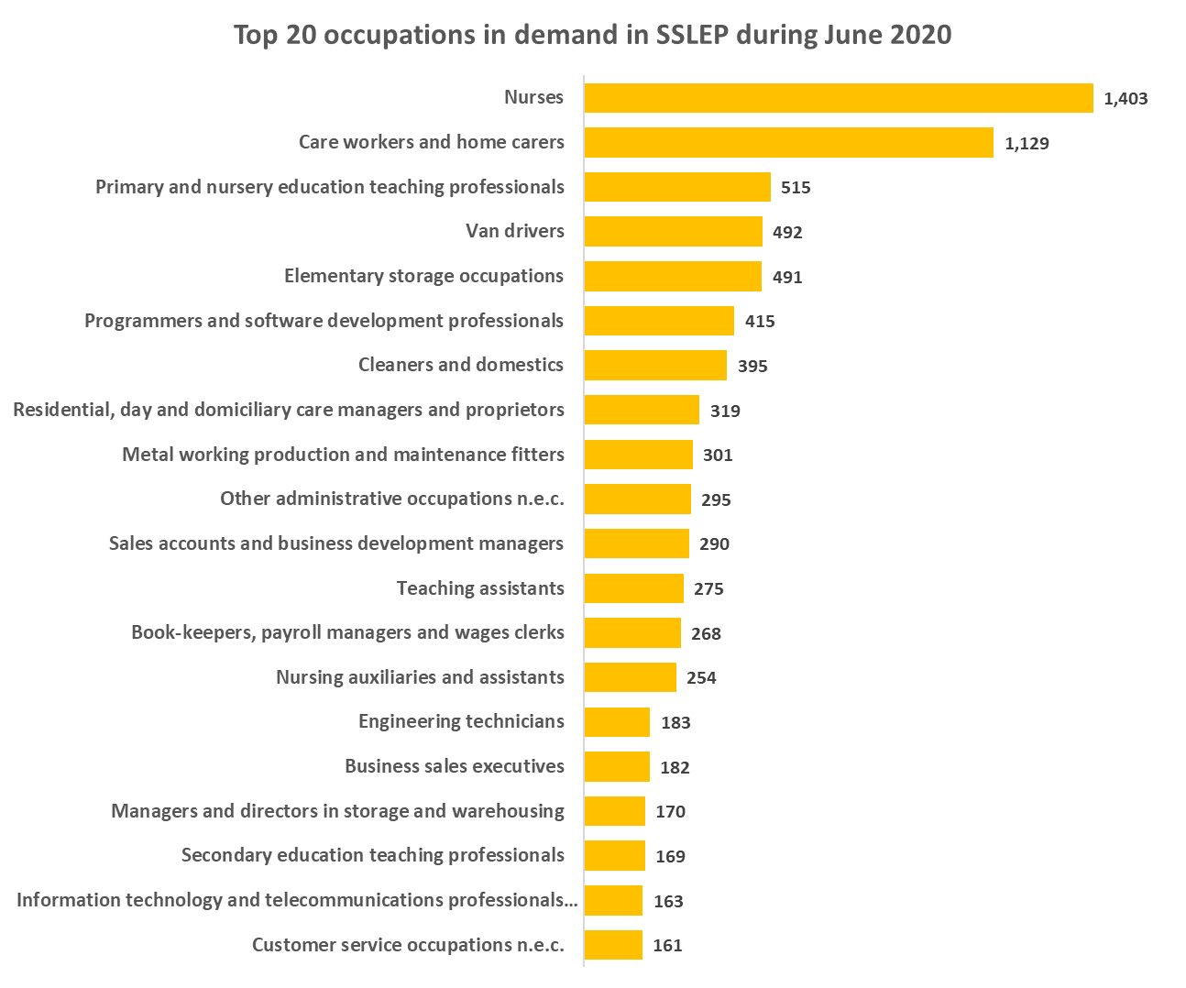

* The overall fall in the number of job vacancies suggests that those unfortunate enough to lose their jobs may struggle to find new ones at least in the short-term, although there are still opportunities available.

**Job Vacancies Summary Table**



**Notes**

**Claimant Count and ILO Unemployment Definitions**

The Claimant Count is a measure of the number of working age people claiming benefits principally for the reason of being unemployed, including those claiming Jobseeker's Allowance plus those who claim Universal Credit and are required to seek work and be available for work.

ILO unemployment data is obtained from the national Labour Force Survey. The definition for unemployment is those without a job, want a job, have actively sought work in the last four weeks and are available to start work in the next two weeks, or; are out of work, have found a job and are waiting to start work in the next two weeks.

**Understanding the differences between the Claimant Count and ILO Unemployment**

According to the UK Claimant Count for May, claimant unemployment increased to 2.8 million and a rate of 7.8% – a rise of 125% in just two months, the fastest rate of growth on record. However, the ILO measure shows that unemployment has remained largely unchanged at around 1.3 million and a rate of 3.9%. Understanding the reasons why there is this difference is important for policymakers trying to determine whether we are currently in the middle of an unemployment crisis or whether this is to come as the Job Retention Scheme (JRS) is gradually withdrawn.

The following section tries to explain this incredibly confusing, complicated and often contradictory data.

The main reasons for the difference between the Claimant Count and ILO measures include:

* **The two measures describe different periods** –for claimant unemployment, the numbers refer to claimants on a specific ‘count date’ with the last three being 12 March, 9 April and 14 May. Therefore these are point-in-time estimates, and handily we can compare what the situation was about a week before the crisis (12 March) with how things were two months later (14 May).

The ILO measure is a three-month average of survey responses between early February and late April 2020. This means that two months pre-date the crisis, while one month (April) is since the crisis began. However, ONS does release [single month estimates](https://www.ons.gov.uk/employmentandlabourmarket/peopleinwork/employmentandemployeetypes/articles/singlemonthlabourforcesurveyestimates/latest) (latest available April 2020) which show a drop in employment in April of 320,000 explained almost entirely by fewer people self-employed but only slight increase of 40,000 unemployed. Instead there is a steep rise in ‘economic inactivity’ which is those who are out of work but are not looking and/ or available for work.

* **Difference in measuring economic inactivity/worklessness** - the Claimant Count measures those who are required to look/be available for work as a condition of benefit, while the ILO measure is those who say that they actually are actively seeking and available for work. The Labour Force Survey is recording a single-month increase in the number of people out of work (unemployed and economically inactive) of 330,000, but nearly 290,000 of these people are not looking for work (economically inactive). The majority of this rise is people previously self-employed and are either not eligible for, or not yet been paid, income under the Self-Employed Income Support Scheme (SEISS).
* **Claimant Count now includes more workers on low-income** - In the Claimant Count, people with earned income can be counted as claimant unemployed if their earnings in the reference month are below a set threshold (£338 per month for a single person, or £541 per month for a couple). Before Universal Credit (UC), short-hours working was penalised and so these numbers were generally low. However, UC incentivises short-hours work, and so we’ve seen a growth in recent years in the number of people treated as being unemployed but who have some earnings. The detailed data for UC suggests that 190,000 of the 1 million increase between March and April was accounted for by working claimants – so around one fifth of the rise.
* **Difference in recording people who are ‘in work’** – in the Labour Force Survey you are recorded as in employment even if you have not done any work that week but ‘have a job or business that you were away from… (and that you expect to return to)”. Obviously this category of workers ‘away’ from work now captures about 9 million people furloughed under the Job Retention Scheme (JRS) who are continuing to earn, but it also includes people who consider themselves to be employees or self-employed but who have no earnings. ‘Real time’ Pay As You Earn data suggests that this may be mainly employees, with the number of paid employees falling by 450,000 between March and April. This 450,000 could include a large number of people who may have been due to start a job in March or April but have been told that they job isn’t available yet and may also be people who had very few or irregular hours before the JRS was introduced and whom employers have not submitted a JRS claim. These people may be describing themselves as being workers with a job that they are away from, rather than as being actively seeking a new job.
* **Benefit take-up/eligibility impact on the Claimant Count** – given that the claimant count only counts those who claim benefit it may be under-stating the growth in worklessness. We know that many unemployed people do not claim, and particularly young people (usually due to eligibility). Under UC, there have been on average 450,000 more ILO unemployed young people than claimant unemployed and even if that gap narrows in the crisis, as tends to happen in recessions, it’s possible that ILO youth unemployment will remain significantly higher than the claimant measure.

**Summary table outlining the potential estimates for the Claimant Count rise in April:**



* It is hoped that this analysis has provided further clarity as to why we have seen such a spike in the number of claimants early in the crisis. What is clear is that we have seen a record fall between March and April in the number of people working and not being supported by JRS. We have also seen worklessness rising at a faster rate than at any time before. Although very few of the decline in the numbers ‘working’ had translated into higher unemployment in April, it is envisaged that this may be the case if people are unable to get back into work quickly.
* Looking forward, the growth in claims for UC is slowing and so the growth in the Claimant Count is also likely to slow as well. That said claimant unemployment is currently at the highest level on record. The main concern now is what happens to many workers as JRS is gradually withdrawn and it is important that we are thinking now about how to support people that are made redundant and what policy interventions are needed.

1. Source: <https://www.nomisweb.co.uk/>
2. Source: HMRC - <https://www.gov.uk/government/statistics/self-employment-income-support-scheme-statistics-july-2020>
3. Source: HMRC - <https://www.gov.uk/government/statistics/self-employment-income-support-scheme-statistics-july-2020>
4. Source: EMSI